My Development Dashboard | Putting It All Together

Top 3 Development Goals
- Development Goal: Measurement:

- Development Goal: Measurement:

- Development Goal: Measurement:
My top 3 strengths as an exemplary leader:
1.
2.
3.

My top 3 growing edges as a leader:
1.
2.
3.

Keep doing:
1.
2.

Start doing:
1.
2.

Stop doing:
1.
2.

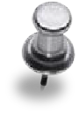
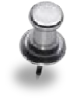
Professional Development Plan post-Fortis Group Program:
1.

2.

3.

4.

5.

My promise:
To myself:

To those I work with:

To the organization:
The Leader Behaviors I will be intentional about practicing are:

1.

2.

3.

4.

5.
My top 5 values 3. are:
1. 4.
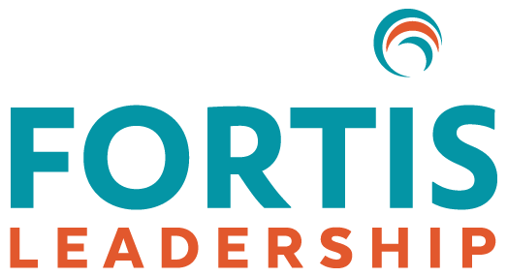
2. 5.
Name Date

